**DOCUMENTATION FOR SCENARIO-1:**

* **What is Scenario-1?**
* **Alice is a new user to the WINGS WORKFLOW SYSTEM.**
* **She just created a new WORKFLOW in WINGS that does SORTING using different algorithms.**

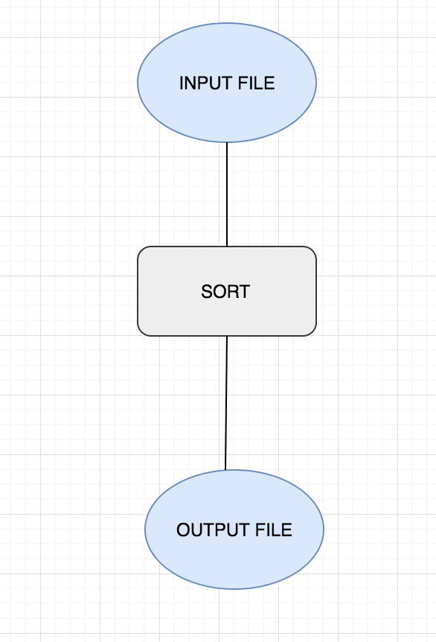

* **She now decides to execute that workflow using QuickSort.**

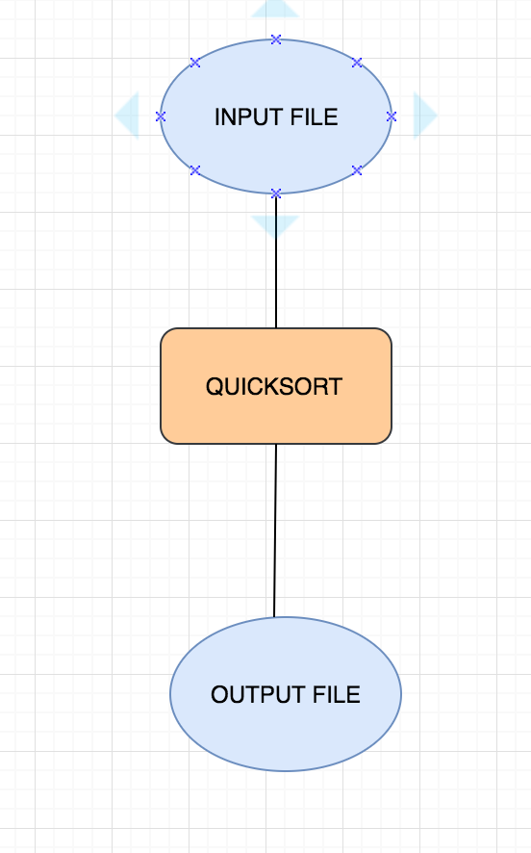

* **She enjoyed executing that workflow and so she decides she wants to use another input file to check whether it works again. So she again executes the same workflow again with QuickSort.**



* **She now knows that this is working really well. She further decides to execute the workflow again, but this time with MergeSort.**

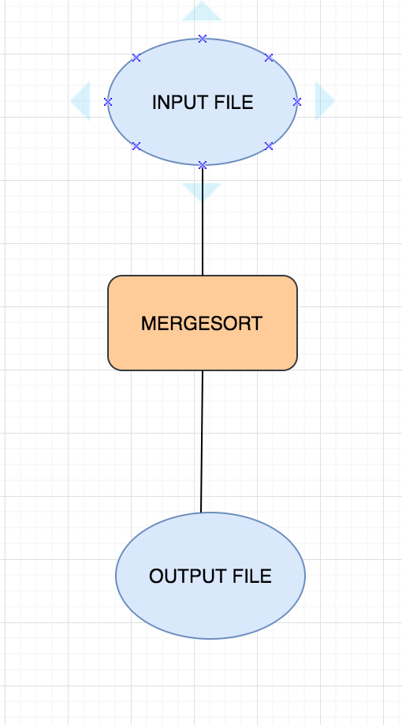

* **She is thrilled to know that it works again even with MergeSort.**

**QUESTIONS/QUERIES TO UNDERSTAND NOW:**

* **Q1: How many abstract templates did she create in this entire procedure?**
* **Ans: Well, she just created only 1 abstract template.**
* **Q2: How many expanded templates did she create in this procedure?**
* **Ans: She has created 2. One with QuickSort and other with MergeSort.**
* **Q3: How many executions did she create in this procedure?**
* **Ans: She has created 3 executions in this case, 2 with QuickSort and 1 with MergeSort.**

**IMPORTANT ASPECTS ABOUT THE CODE:**

* **We have created a signature to identify the uniquely created expanded templates.**
* **Q: How is the signature created?**
* **Ans: The signature is created by taking in all the important relations like inputlinks, outputlinks, datavariables, parameters, and components with the derived from relations (connection to the abstract template). We then take an arrayList of all these strings. We further hash this string with MD5. Now it’s going to be maintained as UNIQUE.**
* **We are currently extracting all aspects of the Expanded Template and seeing to it that the URIs are very well defined and do not clash or go wrong in any way.**
* **The testing queries are maintained in the Validations folder in the GitHub Repository. Please see to it you upload all the necessary results from the mapper in the case when you want to try out anything in the testing cases.**